**IBM NAANMUDHALVAN**

**PHASE 2**

**DOMAIN – ELECTRICITY PRICE PREDICTION**

**PROBLEM STATEMENT:**

Electricity is a basic human need and definitely one of the most important factors of societal progress. In recent decades however, electricity has entered the market as a tradeable commodity and the power industry of many countries has been **deregulated**. In Spain, the Electric Power Act 54/1997 exposed all of the stakeholders to **high amounts of uncertainty** as the price of electricity is determined by countless factors and also, due to the fact that electricity cannot be stored in large quantities efficiently . With the emergence of this new market, the need for reliable forecasting methods at all scales (hourly, daily, long-term, etc.) has also emerged and has become a large area of research.

**SOLUTION:**

**DATA COLLECTION:**

The dataset that we choose to analyze the electricity price prediction. Utilize a dataset containing historical electricity prices and relevant factors like date, demand, supply, weather conditions, and economic indicators.

**DATA PREPROCESSING:**

Clean and preprocess the data by handle missing values, and convert categorical features into numerical representations **.**Also remove punctuation marks, HTML tags, URL’s, successive whitespaces, convert the text to lower case, strip whitespaces from the beginning and the end of the reviews.

**EXPLORATORY DATA ANALYSIS:**

Explore the data to understand its characteristics, observe your dataset, find any missing values, categorize your values , find the shape of dataset ,find relationships in dataset and locate any outliers in dataset.

**DATA VISUALIZATION:**

Visualizations consisting of histograms, box plots, scatter plots, line plots, heat maps, and bar charts assist in identifying styles, trends, and relationships within the facts to present key findings and insights.

**FEATURE ENGINEERING:**

Create additional features that could enhance the predictive power of the model, such as time-based features, data related features, rolling window feature, expanding window feature, domain specific features and lagged variables.

**SOLUTION OVERVIEW:**

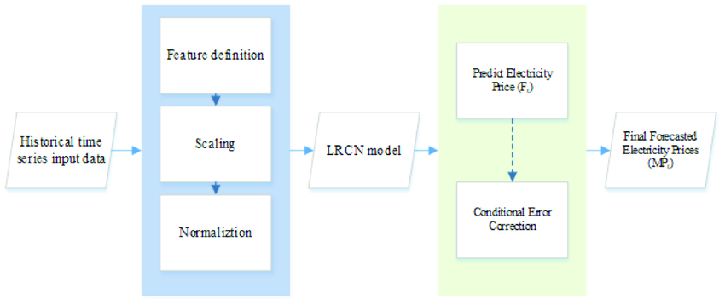

**CONCLUSION:**

Predicting the price of electricity helps a lot of companies to understand how much electricity expenses they have to pay every year.

NAME : HARIS S

COLLEGE CODE: 4204

REGISTER NO :420421106019